Candidate’s Examination Number………………………………..
THE UNITED REPUBLIC OF TANZANIA
PRESIDENT’S OFFICE
REGIONAL ADMINISTRATION AND LOCAL GOVERNMENT
KAGERA REGION FORM TWO MOCK ASSESSMENT,MAY 2020
032 CHEMISTRY

TIME: 2.30 Hours

Instructions
- This paper consists of sections A and B with a total of ten (10) questions.
- Answer all questions in the spaces provided.
- Write your examination number on every page of your answer sheets.
- All writings must be in black or blue ink except for the diagrams which must be in pencil.
- Cellular phones and any unauthorized materials are not allowed in the examination room.
- The following atomic masses may be used:
H=1, C=12, N=14, O=16, Na=23, S=32, C1=35.5, Ca=40, Al=27
K=39, Cu=64, Zn=65, Fe=56, Mg=24.

FOR EXAMINERS USE ONLY
QUESTION NUMBER | SCORE | EXAMINER’S INITIALS
1
2
3
4
5
6
7
8
9
10
TOTAL
CHECKER’S INITIALS

Candidate’s Examination Number………………………………..

SECTION A (20 Marks)
Answer all questions in this section.

1. For each of the items (i) – (x) choose the correct answer from among the given alternatives and write its letter beside the item number in the box provided.
- The following symbols represent proton, electron and neutron respectively:
- 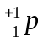, 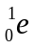and 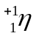.
- 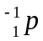, 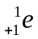 and 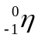.
- P, e and .
- 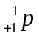 ,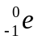 and 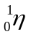 ( )

- The simplest formula of a compound formed when combining 13g of a aluminum and 17g of chlorine is:
- AlCl
- Al₂Cl ( )
- Al₃Cl
- AlCl₃

- A person who get burnt accidentally in the Chemistry laboratory should be given one of the following as first aid:
- Nitric acid
- Petroleum jelly
- Sodium hydroxide
- Antibiotic solution ( )
- The choice of a good source of heat depends on the:
- Colour of the flame
- Quantity and quality of heat produces
- Substance to be heated
- Type and shape of flame ( )

- Which of the following electronic configurations are of metals?
- 2:8:3 and 2:8:8:1
- 2:8:1 and 2:5 ( )
- 2:8:2 and 2:6
- 2:8:6 and 2:8:8:7

- When sugar is dissolved in water, a uniform mixture is formed. What is the name of the resulting mixture :
- Solute ( )
- Solution
- Suspension
- Solvent

Candidate’s Examination Number………………………………..

- Pombe boiled some tea, but didn’t have a sieve, the alternative method she could use to separate tea leaves from liquid tea is:
- Evaporation.
- Decantation.
- Condensation.
- Layer separation ( )

- The second stage in the scientific procedure is:
- Data collection and analysis
- Data interpretation
- Experimentation and observation
- Hypothesis formulation ( )
- One isotope of an element has atomic number A and mass number M. How many neutrons are contained in the nucleus of its atom:
- M
- A
- A – M
- M – A ( )

- A group of apparatuses that are used for collection of gases
- Gas jar, beehive shelf and condenser.
- Gas jar, Beaker and delivery tube.
- Gas jar, delivery tube and beehive shelf.
- Gas jar, trough and condenser. ( )

2(a) Match each item in LIST A with the correct response in LIST B by writing its letter below the number of the corresponding item in the table provided.
LIST A | LIST B
- A flame that sometimes strike back.  - Liquid non – metal.  - Transition element.  - A fire caused by a burning metal.  - Prevent iron from rusting. | - Water  - Bromine  - Non-luminous flame  - Class C fire  - Class D fire  - Oiling  - Variable valence  - Luminous flame
Answers
LIST A | (i) | (ii) | (iii) | (iv) | (v)
LIST B

Candidate’s Examination Number………………………………..

(b) Fill in the blank spaces by using the appropriate terms
i .Liquid does not have a definite shape. Its shape depends on………………………….
ii. It alters the speed of reaction but remains chemically unchanged………………………
iii. Decomposes water into oxygen and hydrogen gas, with the aid of electric current
…………………………………….
iv.The insoluble substances formed during filtration are collectively termed as……………
v/ Group VIII elements are usually referred to as group O elements. They are called ………………………..

SECTION B (80 Marks)
Answer all questions in this section.

3(a) Define the following terms as applied in chemistry;
- Flame……………………………………………………………………………………………………………………………………………………………………
- Bunsen burner……………………………………………………………………
………………………………………………………………………………………..
(b) List four (4) properties of each of the following;
- A luminous flame
………………………………………………………………………………………………………………………………………………………………………………………………………………………………………………………………………………………………………………………………………………………….
- A non-luminous flame
…………………………………………………………………………………………
…………………………………………………………………………………………………………………………………………………………………………………………………………………………………………………………………………………………………………………….

(c ) Write the chemical formula for each the following compound;
- Sodium carbonate………………………………………………………………
- Potassium sulphate………………………………………………………………
- Calcium nitrate…………………………………………………………………….
- Ammonium chloride………………………………………………………………

4(a) Define the following terms;
- Empirical formula………………………………………………………………
………………………………………………………………………………….
………………………………………………………………………………….
………………………………………………………………………………….
- Molecular formula………………………………………………………………
………………………………………………………………………………………
………………………………………………………………………………………
………………………………………………………………………………………

Candidate’s Examination Number………………………………..
(b) A certain compound K contains 15.8% Carbon and 84.2% Sulphur. The molar
mass of K is 76g/mol. Determine its;
- Empirical formula
- Molecular formula

Candidate’s Examination Number………………………………..
5(a) Define with one example
i) Element…………………………………………………………………………………………………………………………………………………………………………………
…………………………………………………………………………………………………………………………………………………………………………………………..

ii)Compound……………………………………………………………………………………………………………………………………………………………………………
…………………………………………………………………………………………

(b) Give one function of each of the following items which are found in the
First Aid Kit.
- Cotton wool…………………………………………………………………………
- Whistle…………………………………………………………………………
- Liniment…………………………………………………………………………
- Plaster………………………………………………………………………………
(c) Differentiate physical change from chemical change
S/N | PHYSICAL CHANGE | CHEMICAL CHANGE
(i)
(ii)
(iii)
(iv)

6.(a) State what is observed when the following simple experiments are performed
- A growing splint is lowered into a jar full of oxygen.
……………………………………………………………………………………………………………………………………………………………………………………………………………………………………………
- A lighted splint is lowered into a gas jar full of hydrogen gas
……………………………………………………………………………………………………………………………………………………………………………………………………………………………………………
- Iron nail is left on open space a week
……………………………………………………………………………………………………………………………………………………………………………………………………………………………………………
- Water is added into a container having anhydrous white Copper (II) sulphate
………………………………………………………………………………………………………………………………………………………………………………………………

Candidate’s Examination Number………………………………..
(b) Give reasons to support the following statements:
- Doors of chemistry laboratory should open outward
………………………………………………………………………………………………………………………………………………………………………………………………………………………………………………………………………………………………
- A chemistry laboratory should have fume chamber
……………………………………………………………………………………………………………………………………………………………………………………………………………………………………………………………………………………………

7. Below is a diagram that represents laboratory preparation of oxygen. Study the diagram and answer the questions that follow.

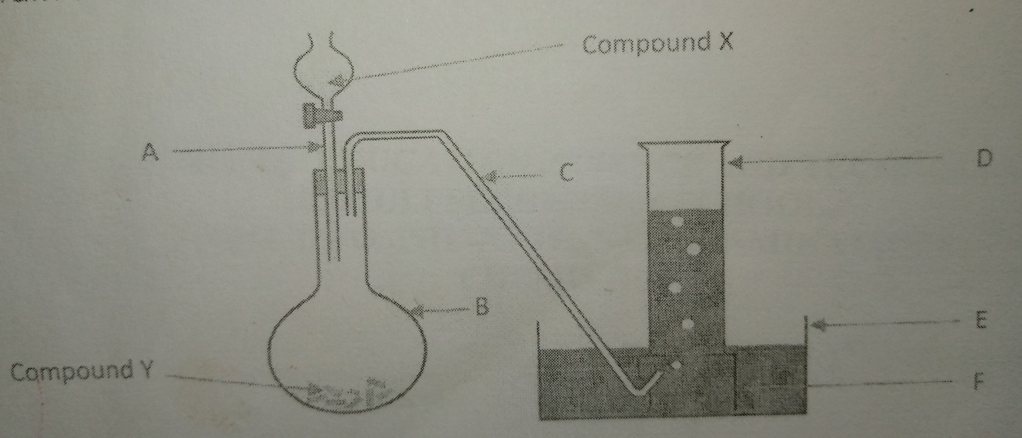

- Name the apparatus labeled A to F
- …………………………………………………………………………………
- …………………………………………………………………………………
- …………………………………………………………………………………
- …………………………………………………………………………………
- …………………………………………………………………………………
- …………………………………………………………………………………
- Name compound X and Y.
Compound X …………………………………………………………………………………………
Compound Y …………………………………………………………………………………………
Candidate’s Examination Number………………………………..
- Which of the two compounds named above in 9(ii) is used as a catalyst?
……………………………………………………………………………………………………………………………………………………………………………………
- Write word equation for the reaction between X and Y
...............................................................................................................................................................................................................................................................................
- Write down four 3 uses of Oxygen
- ………………………………………………………………………………
- ………………………………………………………………………………
- ………………………………………………………………………………
8.(a)Is air a compound or a mixture? Give three points to support your answer.
i ………………………………………………………………………………………………..
ii ……………………………………………………………………………………………….
iii ……………………………………………………………………………………………..
(b) Mention four (4) methods of preventing iron from rusting
- .……………………………………………………………………………………………
- …………..…………………………………………………………………………………
- ………………………………………………………………………………………………
- ……………………………………………………………………………………………
(c) Why we are advised to use alternative source of energy such as solar energy, biogas and wind energy rather than using fossils fuels source of energy. Give two points.
- ………………………………………………………………………………………………………………………………………………………………………………………………
- ………………………………………………………………………………………………………………………………………………………………………………………............
9.a) Define the following terms
i/ Periodic table ………………………………………………………………………………………….………………………………………………………………………………………………………………

Candidate’s Examination Number………………………………..
ii/ Atom …………………………………………………………………………………………………
…………………………………………………………………………………………………
b) Study the following periodic table and answer the questions that follow
I VIII
A | II III IV V VI VII |  |  |  |  |  | B
 |  |  | D |  |  |  | C
 | E
F

- Name the elements A, B, C, D, E and F
……………………………………………………………………………………………………………………………………………………………………………………………………………………………………………………………………………………………………………………………………………………………………………………………………………………………………………………………………
- Draw the electronic structure of atoms E and F

Candidate’s Examination Number………………………………..

(iii) From the structure drawn in 9(a) above state the valence, period and group the atom .
Atom E.Valency …………… Period ….……………Group………….
Atom F. Valency……………Period ……………Group ……………

10.(a) Give the meaning of the following terms
(i) Hydrological cycle
………………………………………………………………………………………………………………………………………………………………………………………………………………………………………………………………………………………………………………………………………………………………………………………………
(ii) Water treatment
………………………………………………………………………………………………………………………………………………………………………………………………………………………………………………………………………………………………
(iii) Water purification
………………………………………………………………………………………………………………………………………………………………………………………………………………………………………………………………………………………………

(b) Write down four (4) main part of the hydrological cycle.
- ……………………………………………………………………………………..
- ……………………………………………………………………………………..
- ……………………………………………………………………………………..
- …………………………………………………………………………………….
(c) What is the function of each of the following chemical in water treatment?
- Aluminum sulfate ……………………………………………………………………………………………………………………………………………………………………………………
- Chlorine ………………………………………………………………………………………………………………………………………………………………………………………………………………………………………………………………………………
- Charcoal ……………………………………………………………………………………………………………………………………………………………………………………

